**Software Engineering Semester 3**

**Architecture Document**

**Online Yearbook**

April 2021

Spartex

|  |
| --- |
| **Date:16/04/2021** |
| **Version:1.0** |
| **State: Complete** |
| **Author: Osuntuyi Michael** |

Version history

|  |  |  |  |  |
| --- | --- | --- | --- | --- |
| **Version** | **Date** | **Author(s)** | **Changes** | **State** |
| 1.0 | 15/04/2021 | Osuntuyi Michael | Document was made | Complete |
|  |  |  |  |  |
|  |  |  |  |  |

Table of Contents

Introduction: 3

Architecture Diagram 3

Diagram Link 3

# Introduction:

The image below represents the architecture diagram of the API logic flow for Online yearbook web application  
Beginning from the Front-end interface to the database.

# Architecture Diagram

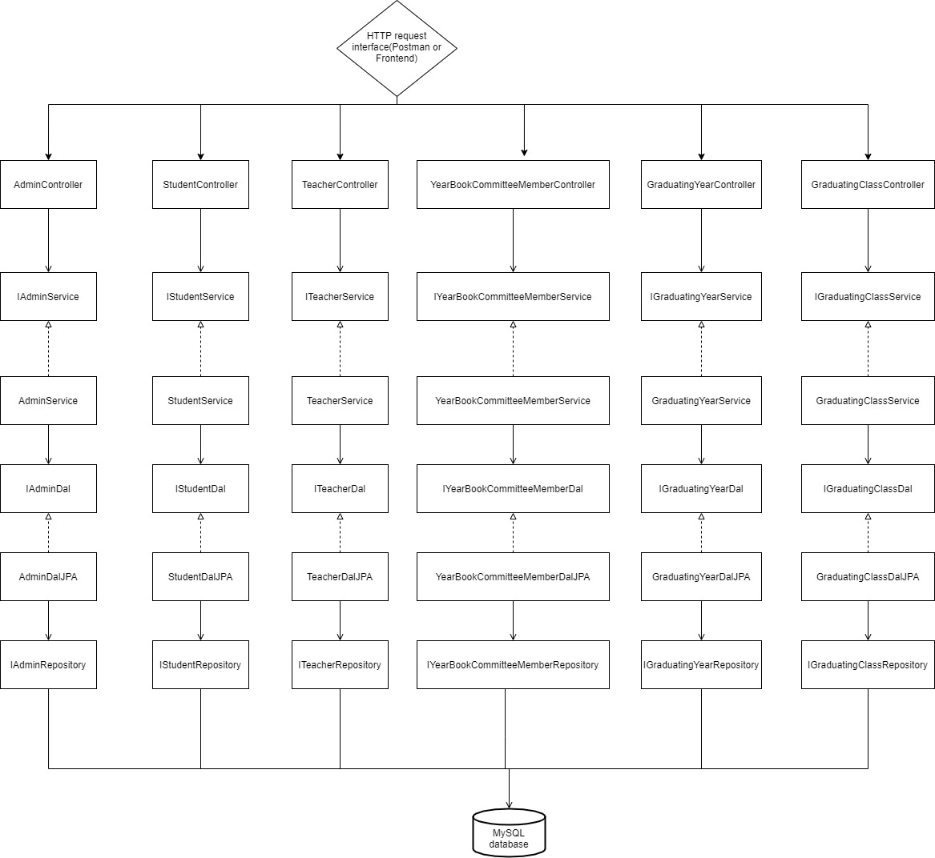

# 

# Diagram Link

The link below is provided for better viewing:

